1. Introduction

Critical thinking skills are important as it helps us to better process and evaluate information that we see, especially when we are inundated with information online. In this Information Age, there are often conflicting pieces of information, as authors attempt to push their own agendas onto the reader. Without critical thinking skills, readers may be misled, taking information at face value. The consequences of these mistruths can ripple, for instance, the anti-vaccine groups around the world. Thus, in order to combat ourselves from such incidents, we have to equip ourselves with critical thinking skills

Ennis’s model splits the guidelines of critical thinking into dispositions and abilities. On the other hand, Paul and Elder’s framework contains various standards, elements and intellectual traits of critical thinking. While these frameworks are fairly comprehensive of what is expected of critical thinking, they contain many details that might overwhelm someone just starting out in learning critical thinking. The frameworks also lack clarity in structure and sequence for readers to apply critical thinking, which can act as barriers to entry.

Having gone through both Ennis and Paul and Elder’s frameworks, we as a group decided to adopt Ennis’s framework due to its more general nature. It also emphasises on the human aspect of critical thinking which we believe to be an important part of any SOP. Furthermore, it addresses fallacies and other issues outside the immediate scope of the text, which we feel was missed out in other frameworks like Paul and Elder.

2. SOP Creation Process

During the creation process, our group agreed to focus on creating a SOP that caters to newcomers rather than experienced critical thinkers. Our group also realised that we need clarity and structure to ensure memorability and proper application. We thus formulated our SOP with these realisations in mind.

Our SOP’s mnemonic is **“ICAN DO IT”**, a phrase of encouragement to those new to critical thinking. While the mnemonic is on the longer side, research shows that the average human mind is able to remember a maximum of 9 characters. **ICAN DO IT** stands for **I**dentify, **C**larify, **A**nnotate, **N**arrow followed by **D**etermine, **O**rganise followed by **I**nvestigate and **T**ransfer.

Our SOP’s mnemonic is not strictly sequential, meaning that each letter does not represent a specific step that must be done in a particular order. However, it is partially sequential in that each word that comprises the mnemonic should be done in order. That is to say, the phrase is split into 3 distinct sections - **“ICAN”**, **“DO”**, and **“IT”**. The ordering of these sections should be followed. A table containing the SOP’s essential ideas and a helpful list of guiding questions can be found in Appendix A.

The main idea behind the SOP is to pass over the text multiple times, each time compressing the text to what is most relevant and significant, increasing our understanding of the argument being presented, as well as progressing our level of analysis of the text.

3. Application of SOP

3.1 Summary

Our chosen text is an opinion article from the New York Times, written by Damon Beres. It focuses on the effects of technology on humans and the planet. We have placed an (annotated) copy of the article in Appendix B for reference.

3.2 First Pass (ICAN)

The first pass mainly focuses on identification and literal comprehension of the text. It involves some form of annotation of the text, with the objective of obtaining a rough understanding of the text, and filter out irrelevant ideas. For written and spoken media, annotation is straightforward using highlighters and writing on the margins. However, in the case of multimodal sources, where transcribing the text would lose too much relevant information, we suggest capturing and editing it on a tablet, computer or smartphone.

For annotations to be useful, one must know what to look out for, and which questions to ask. The SOP provides simple guiding questions for users to leverage on. The first, and most obvious, steps would be to clearly identify what is being communicated - the main issue being discussed and the conclusion provided by the author (*Disposition 1*). A natural progression from that would be to highlight the supporting reasons and evidence for each claim made by the author (*Disposition 2*). It is recommended to use some form of colour coding when annotating for easier reference in the following steps.

Additionally, the SOP reminds users to be alert to assumptions made in the argument, fallacies committed by the author, and also value preferences that he/she seems to hold (*Ability 13*).

Lastly, the SOP guides users to note down clarification questions (*Ability 3*) for sections that were unclear on the first read, and also ambiguity in words or phrases used. By the end of the first pass, users should have a well annotated (and rather messy) version of the text, and a clearer idea of which portions are significant and require further attention. The table below summarises and exemplifies the aforementioned steps by applying them to the text. As mentioned above, the annotated version of the text can be found in Appendix B.

3.3 Second Pass (DO)

While the first pass separates reasons from non-reasons, it does not differentiate between the significance of each reason. This is where the second pass comes in. The objective is to apply a stricter filtering mechanism to the text, by determining their significance and relevance to the main issue (*Ability 9*).

In general, to determine the significance of something, we can ask questions such as: If this were to be the case (or not the case), how would that affect the strength of the argument? For instance, when determining the significance of a reason, we can think about a) the plausibility of it being true, and b) its sufficiency, that is, the extent to which the strength of the reason matches the claim it supports (*Ability 7*).

Additionally, the second pass is where users will organise the text into a simpler, more readable form that outlines the argument and its most salient points (*Ability 17*). While this step is optional as it may seem time consuming, it is recommended that one does not skip it if time permits.

This is because summarising the text in this way forces users to confirm their understanding of the author’s argument, and it also makes the final steps of the SOP more productive, as that involves evaluating the claims in a systematic manner. Users would be more prone to committing fallacies (especially the straw-man fallacy) if they relied on their memory to keep track of the author’s argument.

With reference to this example text, we can readily observe the utility of having a high-level overview of the argument structure at hand (the outline for this text can be found in Appendix C). For instance, notice that the claim for consumers to do more is hardly touched on by the author.

This may be for various reasons, but as critical thinkers, we should question why this is the case. Does this show that the author’s argument is lopsided against manufacturers? Do big companies really ought to carry this much of the responsibility in this problem? Or does this show that the author is biased against corporations? This is a significant observation as it is important to be aware of an author’s leanings.

Additionally, in determining the significance of the claim that *“there is movement afoot to change the current situation”*, we find that it is unnecessary to the author’s main argument, which is that manufacturers and consumers should do more in terms of sustainability and repairability. Therefore, we can direct our resources away from critically evaluating the supporting reasons.

In the interest of brevity, we have included the analysis for a subset of claims:

* 1. *“Manufacturers don’t talk about this turnover (of devices) … This is all by design.”*
     + *“There’s a term for it: planned obsolescence”*
     + *“Ever try to get your TV repaired?”*

This claim is significant because it implicitly suggests that manufacturers are deliberately working against sustainability, likely due to profit interests. If the author did not state that *“this is all by design”*, then the claim would be a weaker statement. However, that phrase turns it into one that we should critically investigate further.

The author’s supporting evidence is mostly rhetoric, and even fallacious. The author commits the fallacy of **explaining by naming** - the fact that planned obsolescence is a term that describes the situation does not mean that manufacturers actually do them. Even though it is likely that the two are correlated, we should not assume that this is the case without any further probing. Moreover, the author cites an even weaker ‘reason’ to explain that planned obsolescence is real, using a rhetorical question.

*2. “If they (manufacturers) won’t (change), governments must make them.”*

This claim is unsupported, perhaps the author **implicitly assumes** that if an issue is large and ‘bad’ enough, then there is strong cause for government intervention. Even though there may be good reasons for this, as critical evaluators, we should question this assumption: Should we turn to government regulation for such a problem? Are there drawbacks to such a solution? What is/are the alternative(s)? The author did state that *“if unrepairable gadgets don’t sell, manufacturers will change course”*, acknowledging the effectiveness of the free-market to regulate such behaviour, and in turn, the consumers’ power to do so. Hence, we should not blindly accept that the government directly mandating manufacturers is the only good solution to this problem

*3. “Although tech companies will often speak of sustainability, many lobby against repair legislation”*

* *“(They are) fearful it will loosen their control and eat into their profits”*

This is a factual claim; it can be verified (mostly) objectively. However, the author does not give appropriate evidence to support it. Rather, the  reason given merely begs the question. We may trust that the author has done the appropriate research, and that the NYT is a reputable source. However, if we want to be rigorous, we can verify this for ourselves, since it is a significant claim to the whole argument. If only a few tech companies lobbied against repair legislation, then the cause of this issue may lie somewhere else.

*4. “Sustainability matters, but marketable design appears to matter more to these companies.”*

* *“Consumers are urged to upgrade annually”*
* *“Well north of 1 billion smartphones were shipped in 2020”*
* *“None of Apple’s iPhones or MacBooks earned above a 7, with 10 being the top score — making the company a C student at best … Other manufacturers like Microsoft and Samsung fared about the same.”*

This is a well-supported claim. Therefore, the questions we can ask are: Is it reasonable to mandate manufacturers to (or think that they must) prioritise sustainability over profit-motives? To allocate resources toward, for example, R&D relating to sustainability? The value conflict here is mainly between **social responsibility and freedom of choice**. That is, the author seems to believe that the manufacturer’s responsibility to minimise environmental damage should be valued more highly than their freedom to pursue their own objectives

3.3 Third Pass (IT)

In the final section of the SOP, users should ideally be dealing with the most significant ideas of the text. Therefore, we can focus on them and rigorously evaluate their validity or truth using critical reasoning or research. The objective of the third pass is to evaluate the overall soundness of the argument presented, to come up with their own conclusion on the issue, and to think of the implications of the message.

To achieve this, the SOP tasks its users to investigate and evaluate each reason. The SOP recommends playing the role of devil’s advocate as an effective starting point for critical evaluation (*Disposition 8, Ability 14*). It suggests that users ask questions such as “What reasons would someone who disagrees offer?” and “Does the author address them in any meaningful manner?”. This reminds users that on the surface, an argument will almost always be dressed in its best clothes as the author wishes to convince them of their view.

After each claim has been individually tested, the SOP guides users to evaluate the overall validity of the author’s conclusion. In doing so, the SOP also prevents users from falling into the trap of rigid and dichotomous thinking, through guiding questions such as “What other reasonable conclusions are possible?” and “Does the strength of the author’s conclusion match that of the reasons provided?”.

One can gauge the strength of a statement by the use of if-clauses to precede them, as they acknowledge that the statement is based on particular claims or assumptions about which the author is uncertain. By identifying reasonable alternative conclusions, users can determine which of those, if any, they would be willing to accept in place of the author’s conclusion (*Disposition 9*).

3.4 Evaluation of SOP

4. Concluding Remarks

From the usage of our SOP, we could easily break on the article using the prompts at each step. We were also able to identify fallacies and certain ambiguous arguments, but eventually we found that the article was well presented and good arguments to justify their stance of supporting electronics that last and that can be easily repaired.

In a nutshell, the advantage of using our SOP is that we could encapsulate more points from Ennis’s model to teach beginners about applying critical thinking skills. The 3-pass method also separates these points into clear steps that the reader should take when analysing information. While the 3-pass method may be time consuming, it is to break down and engrain these steps for the reader. Eventually, critical thinkers will be well-familiarised to apply all these steps concurrently into 1 pass to analyse text or media quickly.

By applying our SOP to online text regularly, we will gradually improve our critical thinking skills such that it will become second nature to us.

5. References

1. MILLER, G. A. (January 01, 1956). The magical number seven plus or minus two: some limits on our capacity for processing information. Psychological Review, 63, 2, 81-97.
2. Ennis, R. (2015). Critical thinking: A streamlined conception. In M.Davieset al. (Eds) The Palgrave Handbook of Critical Thinking in Higher Education

6. Distribution of Roles

|  |  |  |
| --- | --- | --- |
| Team Member | Role(s) in Project Paper | Role(s) in OP |
| Wong Peng Xiang | Introduction and Conclusion | Speaker 1 (Introduction and Conclusion) |
| Yuvaraj Kumaresan | SOP Introduction | Speaker 2 (SOP Introduction) |
| Choi Minseok | Summary of Source and Application of SOP 1st Pass | Speaker 3 (Application of SOP 3rd Pass) |
| Brandon Thio | Application of SOP 2nd Pass | Speaker 4 (Application of SOP 2nd Pass) |
| Michelle Yong Kai Wen | Application of SOP 3rd Pass and Efficacy of SOP | Speaker 5 (Application of SOP 3rd Pass and Summary) |

7. Appendix

**Appendix A (SOP Guidelines)**

**Appendix B (Annotated Source Text)**

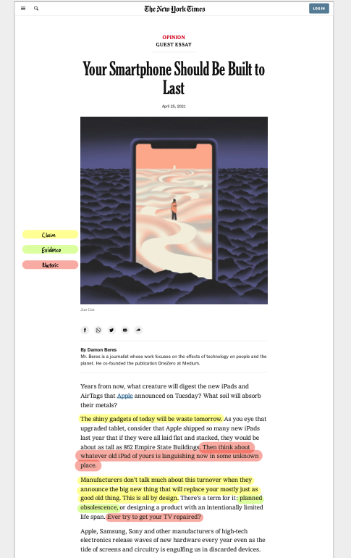

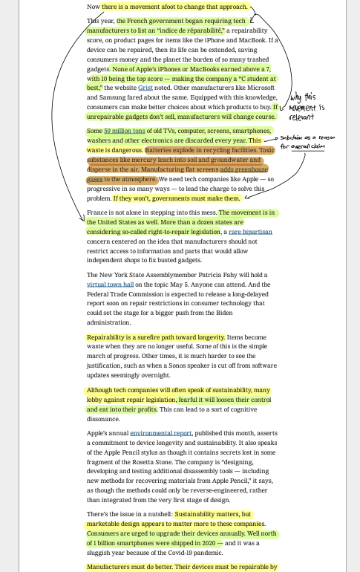

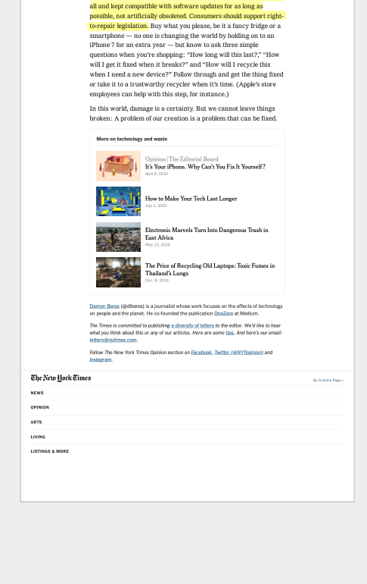

**Appendix C (Example Outline)**

**Overarching Claim**

“Manufacturers must do better. Their devices must be repairable by all and kept compatible with software updates for as long as possible, not artificially obsoleted.”

|  |  |  |  |
| --- | --- | --- | --- |
| Claim | | Reasons / Evidence | |
| “Manufacturers don’t talk about this turnover (of devices) … This is all by design.” | * “There’s a term for it: planned obsolescence” * “Ever try to get your TV repaired?” | |
| “If they (manufacturers) won’t (change), governments must make them.” |  | |
| “Although tech companies will often speak of sustainability, many lobby against repair legislation” | * “(They are) fearful it will loosen their control and eat into their profits” | |
| “This waste (from discarded electronics) is dangerous” | * “Consumers are urged to upgrade annually” * “Well north of 1 billion smartphones were shipped in 2020” * “None of Apple’s iPhones or MacBooks earned above a 7, with 10 being the top score — making the company a C student at best … Other manufacturers like Microsoft and Samsung fared about the same.” | |
| “There is movement to change the current situation” | * The French government recently mandated tech manufacturers to list repairability scores on product pages * “More than a dozen states in the US are considering right-to-repair legislation” * “New York State Assembly is organising a virtual town hall open to the public” * “Federal Trade Commission is expected to release a report of repair restrictions in consumer technology” | |